
Sreenidhi Institute of Science and Technology
Regulations:
A12
(An Autonomous Institution)
Code No: 3B729 Date:9-Dec-16(FN)
B. TECH. IV-Year I-Semester Examinations, Nov/Dec 2016 (Supplementary)
ROBOTICS (ME)

Time: 3 Hours Max. Marks: 70
Note: a) No additional answer sheets will be provided.
b) All sub-parts of a question must be answered at one place only, otherwise it will not be valued.
c) Assume any missing data

Part - A
Max.Marks:20

Answer all QUESTIONS. EACH QUESTION CARRIES 2 MARKS.
- Give a brief classification of actuators used in robotics.
- What are the features of robots in material handling?
- List out three different types of grippers commonly used.
- What is meant by skew motion?
- Define PID and write its advantages?
- What is the use of sensors in robotics?
- Name a few typical applications of an industrial robot?
- Define Trajectory planning.
- List out different path control modes in robotics.
- What are the image devices used in robot lighting techniques?
Part – B
Max.Marks:50
ANSWER ANY FIVE QUESTIONS. EACH QUESTION CARRIES 10 MARKS.

- a) What are the different types of actuators used for Robots? Specify advantages & disadvantages of each
b) Describe the applications of Robotics.
- State the important steps in Denavit - Hartenberg ( D - H ) convention and explain how Homogenous transformation matrix derived.
- Using the Lagrange - Euler formulations, determine the equation of motion for the RP manipulator shown in figure give below.
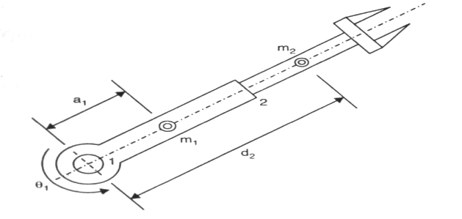

4. a) Define straight line motion and give an example? 2M
b) A two degree of freedom planar robot is to follow a straight line between the start (3,10)cm and the end (8 , 15) cm points of the motion segment. Find the joint variable for the robot if the path is divided into 5 segments. Assume each link is 10 cm long. 8M

5. a) Explain transfer function representation of feedback control with a neat sketch?
b) Transfer function (TF) of a system is given as G(s) = 0.2 / (0.1s² + 0.6s +1) ,
Find its natural frequency and damping ratio?

6. Explain the following sensors in brief with a neat sketch,
(i) Position sensors
(ii) Velocity sensors
(iii) Acceleration sensors
(iv) Force sensors

7. With the help of block diagram, explain the functions of a robotic vision system and devices used in the same. Enlist the features of Sensors & transducers.

8. a) The end effector of a manipulator is to exert a force of f = 0i +0j +10k and a moment of m= 0i + 0j - 100k. The position of the end effector is described by

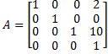

Determine the equivalent moment and force at the wrist? (7M)
b) List out the steps involved to arrive at the dynamic equation of a general manipulator. (3M)

-- 00 -- 00 --

